Chapter 9, Solution 38.

Using Fig. 9.45, design a problem to help other students to better understand admittance.

Although there are many ways to work this problem, this is an example based on the same kind of problem asked in the third edition.

Problem

Find i(t) and v(t) in each of the circuits of Fig. 9.45.

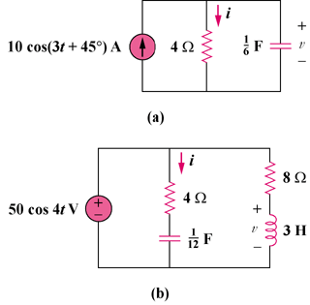

Figure 9.45

Solution

Hence, i(t) = 4.472 cos(3t – 18.43) A

Hence, v(t) = 17.89 cos(3t – 18.43) V

Hence, i(t) = 10 cos(4t + 36.87) A

Hence, v(t) = 41.6 cos(4t + 33.69) V

